SRM INSTITUTE OF SCIENCE AND TECHNOLOGY

DEPARTMENT OF COMPUTING TECHNOLOGIES

OODP ASSIGNMENT

DATE: 22-12-2021

REGISTER NUMBERS: RA2011003010897

RA2011003010905

RA2011003010923

RA2011003010928

RA2011003010966

STUDENT NAMES: Apoorva Gupta

Muhammad Waseem

Sahil Aggarwal

Sumanshu Anand

Dhruv Pandoh

FACULTY NAME: Sowmiya B

|  |  |  |
| --- | --- | --- |
| INDEX | | |
| S.No | Title | Page |
| 1 | Use Case Diagram |  |
| 2 | Class Diagram |  |
| 3 | Sequence Diagram |  |
| 4 | Collaboration Diagram |  |
| 5 | State Chart Diagram |  |
| 6 | Activity Diagram |  |
| 7 | Component Diagram |  |
| 8 | Deployment Diagram |  |
| 9 | Package Diagram |  |

LIST OF FIGURES

Class Diagrams

UML Class Diagram is a type of Structure Diagrams that shows the classes of a system, attributes, operations, and the relationships between them.

Package Diagrams

UML Package Diagram is a type of Structure Diagrams that represents the packages of the model and dependencies between them.

Use Case Diagrams

UML Use Case Diagram is a type of behavioral diagrams that displays the dependencies between the actors and use cases. UML Use Case Diagram displays the system on the conceptual level.

Sequence Diagrams

UML Sequence Diagram is a type of Interaction Diagrams that describes the interactions between objects and classes that are involved in the scenario and the sequence of messages exchanged between them.

Collaboration Diagrams

UML Communication Diagram in UML 2.0 (Collaboration Diagram in UML 1.x) is a type of Interaction Diagrams that displays the interactions of objects using the sequenced messages.

Activity Diagrams

UML Activity Diagram is a type of Behavior Diagrams that graphically describes decomposition of some activity on the components.

Component Diagrams

UML Component Diagram is a type of Structure Diagrams that shows how components are connected to larger components or software systems, and shows the dependencies among these components.

Deployment Diagrams

UML Deployment Diagram is a type of Structure Diagrams that shows the physical deployment of information generated by the software programs.

State Machine Diagrams

UML State Machine Diagram is a type of Behavior Diagrams that displays the finite state machine with states and state transitions.

Timing Diagrams

UML Timing Diagram in the UML 2.0 is a specific type of Interaction Diagrams that describes the timing constraints. UML Timing Diagrams describes the behaviors of the objects during a certain period of time.

INTRODUCTION

Instagram is an American [photo](https://en.wikipedia.org/wiki/Photo) and [video sharing](https://en.wikipedia.org/wiki/Video_sharing) [social networking service](https://en.wikipedia.org/wiki/Social_networking_service) founded by [Kevin Systrom](https://en.wikipedia.org/wiki/Kevin_Systrom) and [Mike Krieger](https://en.wikipedia.org/wiki/Mike_Krieger). The app allows users to upload media that can be edited with [filters](https://en.wikipedia.org/wiki/Photographic_filter) and organized by [hashtags](https://en.wikipedia.org/wiki/Hashtag) and [geographical tagging](https://en.wikipedia.org/wiki/Geotag). Posts can be shared publicly or with pre-approved followers. Users can browse other users' content by tags and locations and view trending content. Users can [like](https://en.wikipedia.org/wiki/Like_button) photos and follow other users to add their content to a personal [feed](https://en.wikipedia.org/wiki/News_feed).

Courtesy: Wikipedia

This project explains the process of creating an Instagram account with the use of the above mentioned UML diagrams.

Purpose:

In today’s world, Instagram is widely used. Apart from using this for leisure, people take this platform in a professional manner. This project helps in engaging with the platform by beginning with the first step, creating an account in Instagram.

INTERFACE REQUIREMENT

User Interface:

Instagram uses flat design in its interface so it doesn't have the usual drop shadows or inner shadows to indicate that you can press on the links and buttons but it does use the differentiation of colors to educate the users.

Hardware Interface:

This application works in Android, iOS and Windows. This application is less compatible on PCs/Laptops.

Software Interface:

The Android version was released in April 2012, followed by a feature-limited desktop interface in November 2012, a Fire OS app in June 2014, and an app for Windows 10 in October 2016. As of October 2015, over 40 billion photos had been uploaded.

Communication Interface:

Instagram can help promote commercial products and services. It can be distinguished from other social media platforms by its focus on visual communication. Instagram marketing is an effective way to advertise a product, given that a picture is said to speak a thousand words. The platform can also help commercial entities save branding costs, as it can be used for free even for commercial purposes.

The motives for using Instagram among young people are mainly to look at posts, particularly for the sake of social interactions and recreation. In contrast, the level of agreement expressed in creating Instagram posts was lower, which demonstrates that Instagram's emphasis on visual communication is widely accepted by young people in social communication.

* Use Case Diagram:

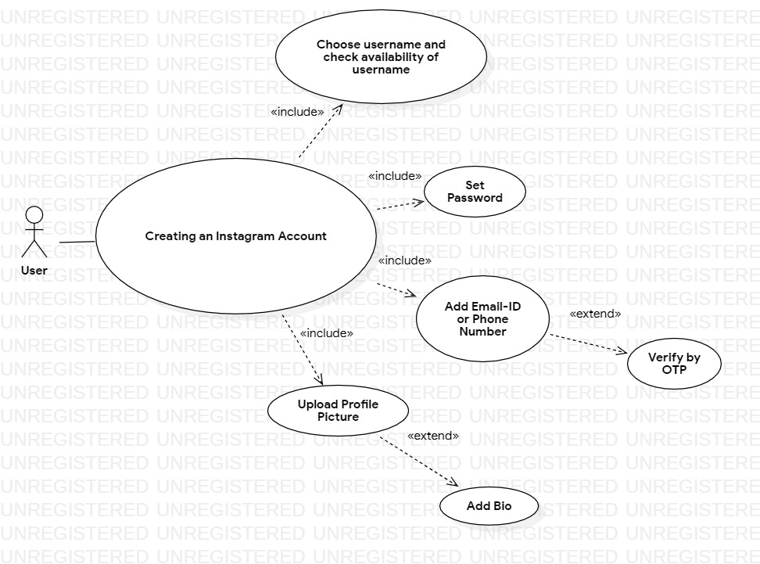

* Class Diagram:

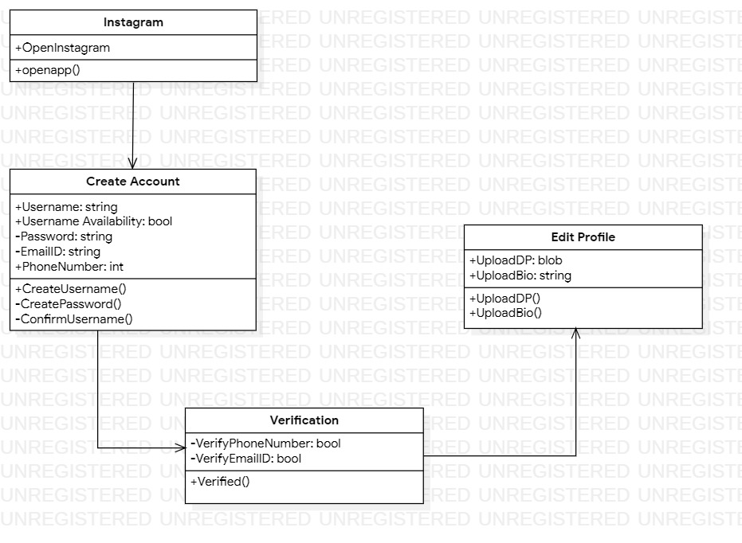

* Sequence Diagram:

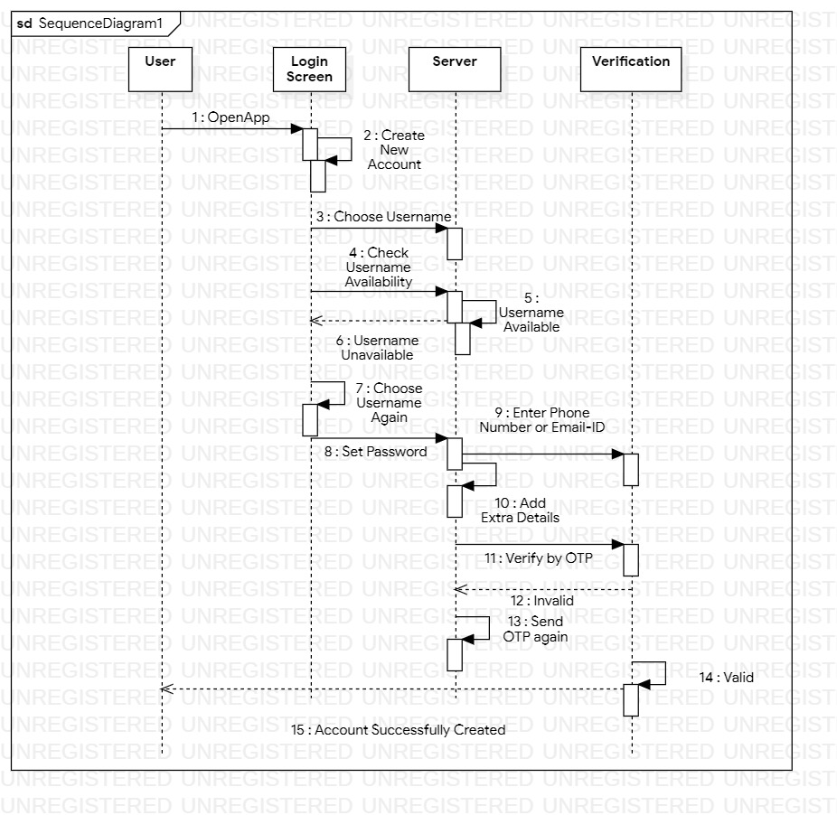

* Collaboration Diagram:

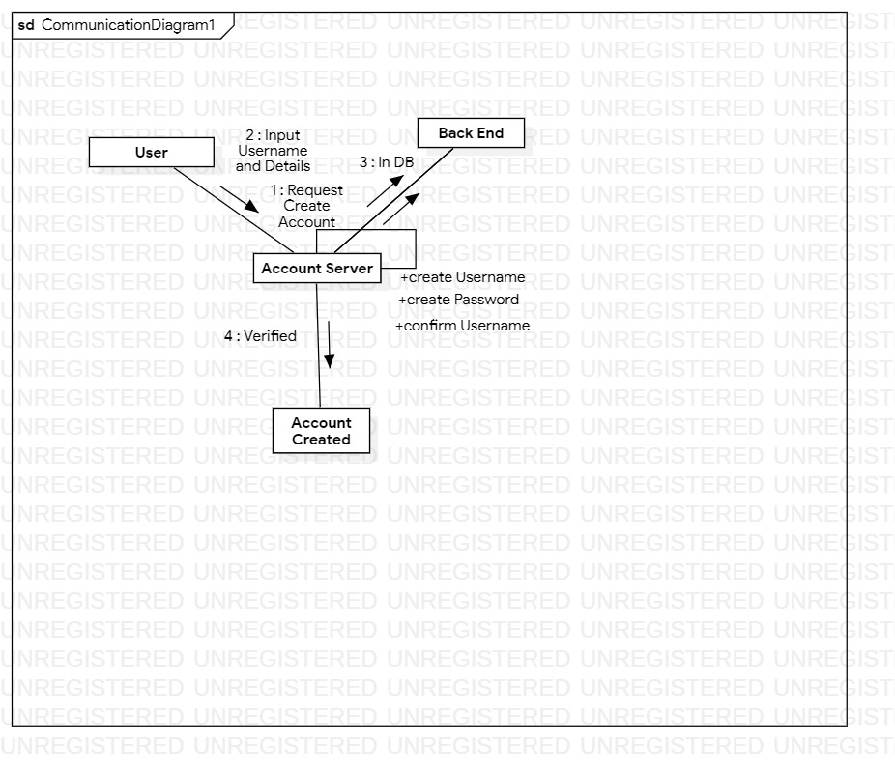

* State Chart Diagram:

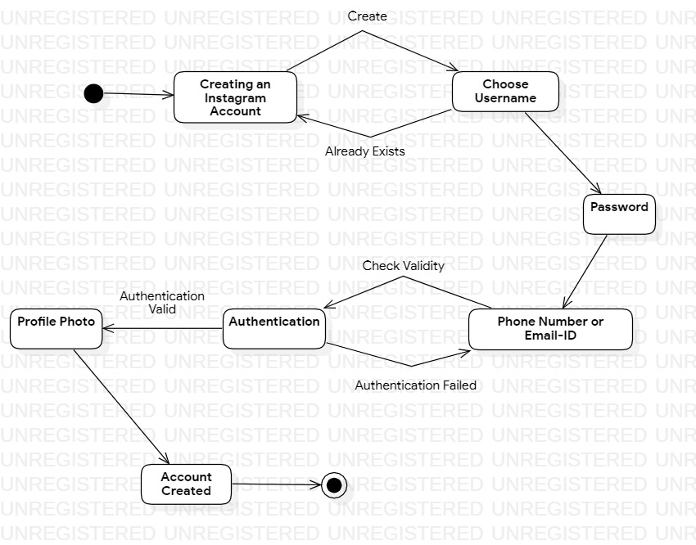

* Activity Diagram:

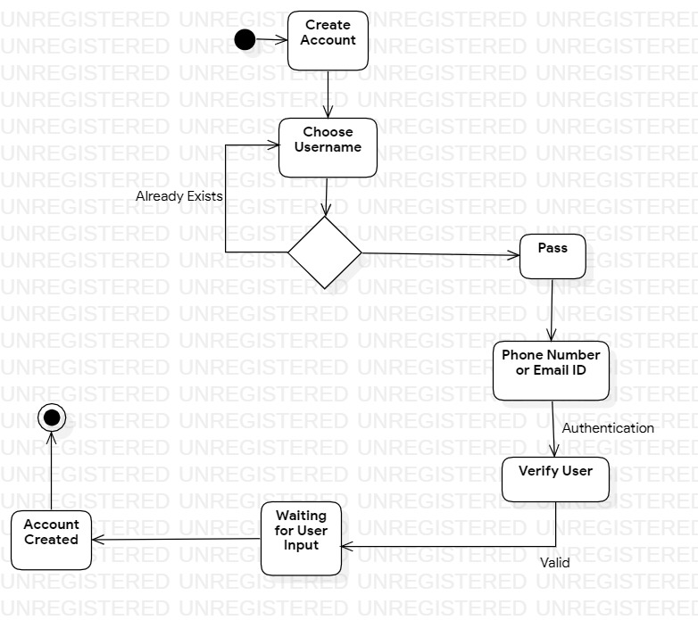

* Component Diagram:

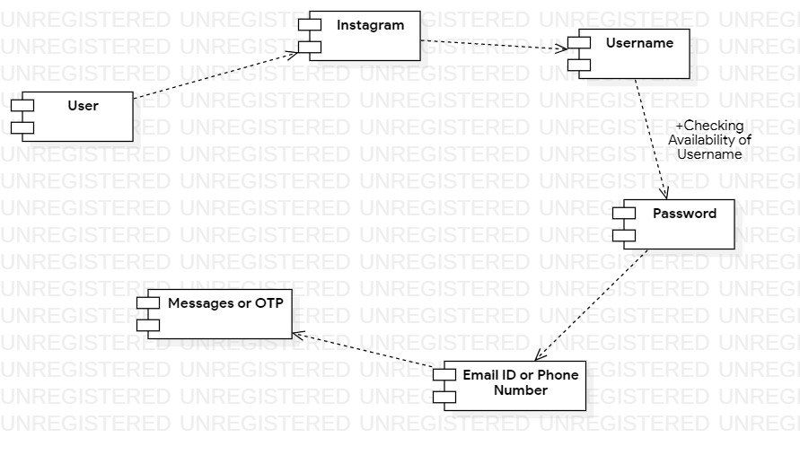

* Deployment Diagram:

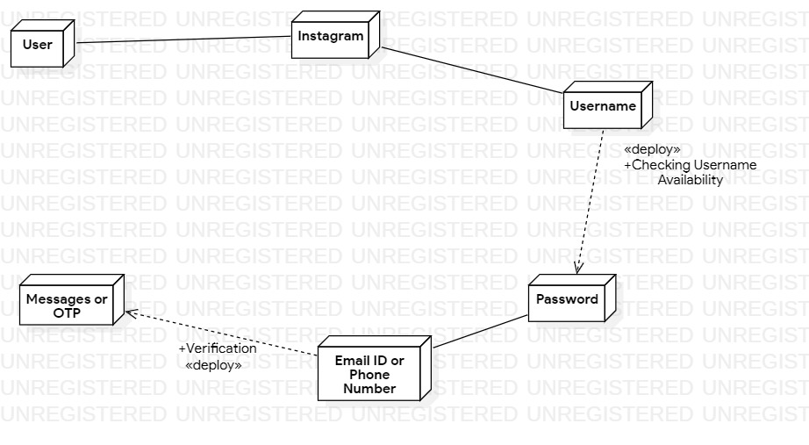

* Package Diagram:

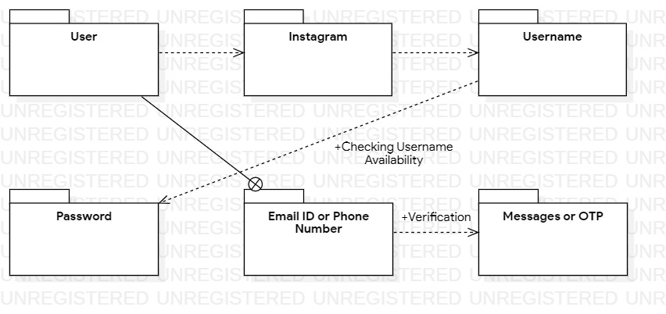

CONCLUSION

At the conclusion, UML can be defined as a modeling language to capture the architectural, behavioral and structural aspects of a system. Objects are the key to this object-oriented world. The basic requirement of object-oriented analysis and design are to identify the object efficiently.

--------